**1.5. Ubuntu 14**

On a server host that has Internet access, use a command line editor to perform the following steps:

1. Log in to your host as root.
2. Download the Ambari repository file to a directory on your installation host.

wget -nv http://public-repo-1.hortonworks.com/ambari/ubuntu14/2.x/updates/2.1.2/ambari.list -O /etc/apt/sources.list.d/ambari.list

apt-key adv --recv-keys --keyserver keyserver.ubuntu.com B9733A7A07513CAD

apt-get update

|  |  |
| --- | --- |
| [Important] | **Important** |
| Do not modify the ambari.list file name. This file is expected to be available on the Ambari Server host during Agent registration. |

1. Confirm that Ambari packages downloaded successfully by checking the package name list.

apt-cache showpkg ambari-server

apt-cache showpkg ambari-agent

apt-cache showpkg ambari-metrics-assembly

You should see the Ambari packages in the list.

1. Install the Ambari bits. This also installs the default PostgreSQL Ambari database.

apt-get install ambari-server

|  |  |
| --- | --- |
| [Note] | **Note** |
| When deploying HDP on a cluster having limited or no Internet access, you should provide access to the bits using an alternative method.  For more information about setting up local repositories, see [Using a Local Repository](http://docs.hortonworks.com/HDPDocuments/Ambari-2.1.2.0/bk_Installing_HDP_AMB/content/_using_a_local_repository.html).  Ambari Server by default uses an embedded PostgreSQL database. When you install the Ambari Server, the PostgreSQL packages and dependencies must be available for install. These packages are typically available as part of your Operating System repositories. Please confirm you have the appropriate repositories available for the postgresql-server packages. |

## 2. Set Up the Ambari Server

Before starting the Ambari Server, you **must** set up the Ambari Server. Setup configures Ambari to talk to the Ambari database, installs the JDK and allows you to customize the user account the Ambari Server daemon will run as. The ambari-server setup command manages the setup process. Run the following command on the Ambari server host to start the setup process. You may also append [Setup Options](http://docs.hortonworks.com/HDPDocuments/Ambari-2.1.2.0/bk_Installing_HDP_AMB/content/_setup_options.html) to the command.

ambari-server setup

Respond to the setup prompt:

1. If you have not temporarily disabled SELinux, you may get a warning. Accept the default (y), and continue.
2. By default, Ambari Server runs under root. Accept the default (n) at the Customize user account for ambari-server daemon prompt, to proceed as root. If you want to create a different user to run the Ambari Server, or to assign a previously created user, select y at the Customize user account for ambari-server daemon prompt, then provide a user name. Refer to the Ambari Security Guide > [Configuring Ambari for Non-Root](http://docs.hortonworks.com/HDPDocuments/Ambari-2.1.2.0/bk_Ambari_Security_Guide/content/_configuring_ambari_for_non-root.html), for more information about running the Ambari Server as non-root.
3. If you have not temporarily disabled iptables you may get a warning. Enter y to continue.
4. Select a JDK version to download. Enter 1 to download Oracle JDK 1.8.

|  |  |
| --- | --- |
| [Note] | **Note** |
| JDK support depends entirely on your choice of HDP Stack versions. Please refer to the [Ambari Reference Guide](http://docs.hortonworks.com/HDPDocuments/Ambari-2.1.2.0/bk_ambari_reference_guide/content/ch_changing_the_jdk_version_on_an_existing_cluster.html) to see which JDK versions are supported by the HDP Stack version you intend to install. By default, Ambari Server setup downloads and installs Oracle JDK 1.8 and the accompanying Java Cryptography Extension (JCE) Policy Files. If you plan to use a different version of the JDK, see [Setup Options](http://docs.hortonworks.com/HDPDocuments/Ambari-2.1.2.0/bk_Installing_HDP_AMB/content/_setup_options.html) for more information. |

1. Accept the Oracle JDK license when prompted. You must accept this license to download the necessary JDK from Oracle. The JDK is installed during the deploy phase.
2. Select n at Enter advanced database configuration to use the default, embedded PostgreSQL database for Ambari. The default PostgreSQL database name is ambari. The default user name and password are ambari/bigdata. Otherwise, to use an existing PostgreSQL, MySQL or Oracle database with Ambari, select y.
   * If you are using an existing PostgreSQL, MySQL, or Oracle database instance, use one of the following prompts:

|  |  |
| --- | --- |
| [Important] | **Important** |
| You must prepare a non-default database instance, using the steps detailed in [Using Non-Default Databases-Ambari](http://docs.hortonworks.com/HDPDocuments/Ambari-2.1.2.0/bk_ambari_reference_guide/content/_using_non-default_databases_-_ambari.html), before running setup and entering advanced database configuration. |
| [Important] | **Important** | |
| Using the **Microsoft SQL Server** or **SQL Anywhere** database options are not supported. | |

* + To use an existing Oracle instance, and select your own database name, user name, and password for that database, enter 2.

Select the database you want to use and provide any information requested at the prompts, including host name, port, Service Name or SID, user name, and password.

* + To use an existing MySQL database, and select your own database name, user name, and password for that database, enter 3.

Select the database you want to use and provide any information requested at the prompts, including host name, port, database name, user name, and password.

* + To use an existing PostgreSQL database, and select your own database name, user name, and password for that database, enter 4.

Select the database you want to use and provide any information requested at the prompts, including host name, port, database name, user name, and password.

1. At Proceed with configuring remote database connection properties [y/n] choose y.
2. Setup completes.

|  |  |
| --- | --- |
| [Note] | **Note** |
| If your host accesses the Internet through a proxy server, you must configure Ambari Server to use this proxy server. See [How to Set Up an Internet Proxy Server for Ambari](http://docs.hortonworks.com/HDPDocuments/Ambari-2.1.2.0/bk_ambari_reference_guide/content/ch_setting_up_an_internet_proxy_server_for_ambari.html) for more information. |

## 3. Start the Ambari Server

* Run the following command on the Ambari Server host:

ambari-server start

* To check the Ambari Server processes:

ambari-server status

* To stop the Ambari Server:

ambari-server stop

|  |  |
| --- | --- |
| [Note] | **Note** |
| If you plan to use an existing database instance for Hive or for Oozie, you must complete the preparations described in [Using Non-Default Databases-Hive](http://docs.hortonworks.com/HDPDocuments/Ambari-2.1.2.0/bk_ambari_reference_guide/content/_using_non-default_databases_-_hive.html) and [Using Non-Default Databases-Oozie](http://docs.hortonworks.com/HDPDocuments/Ambari-2.1.2.0/bk_ambari_reference_guide/content/_using_non-default_databases_-_oozie.html) **before** installing your Hadoop cluster. |

## Chapter 3. Installing, Configuring, and Deploying a HDP Cluster

Use the Ambari Install Wizard running in your browser to install, configure, and deploy your cluster, as follows:

* [Log In to Apache Ambari](http://docs.hortonworks.com/HDPDocuments/Ambari-2.1.2.0/bk_Installing_HDP_AMB/content/_log_in_to_apache_ambari.html)
* [Name Your Cluster](http://docs.hortonworks.com/HDPDocuments/Ambari-2.1.2.0/bk_Installing_HDP_AMB/content/_name_your_cluster.html)
* [Select Stack](http://docs.hortonworks.com/HDPDocuments/Ambari-2.1.2.0/bk_Installing_HDP_AMB/content/_select_stack.html)
* [Install Options](http://docs.hortonworks.com/HDPDocuments/Ambari-2.1.2.0/bk_Installing_HDP_AMB/content/_install_options.html)
* [Confirm Hosts](http://docs.hortonworks.com/HDPDocuments/Ambari-2.1.2.0/bk_Installing_HDP_AMB/content/_confirm_hosts.html)
* [Choose Services](http://docs.hortonworks.com/HDPDocuments/Ambari-2.1.2.0/bk_Installing_HDP_AMB/content/_choose_services.html)
* [Assign Masters](http://docs.hortonworks.com/HDPDocuments/Ambari-2.1.2.0/bk_Installing_HDP_AMB/content/_assign_masters.html)
* [Assign Slaves and Clients](http://docs.hortonworks.com/HDPDocuments/Ambari-2.1.2.0/bk_Installing_HDP_AMB/content/_assign_slaves_and_clients.html)
* [Customize Services](http://docs.hortonworks.com/HDPDocuments/Ambari-2.1.2.0/bk_Installing_HDP_AMB/content/_customize_services.html)
* [Review](http://docs.hortonworks.com/HDPDocuments/Ambari-2.1.2.0/bk_Installing_HDP_AMB/content/_review.html)
* [Install, Start and Test](http://docs.hortonworks.com/HDPDocuments/Ambari-2.1.2.0/bk_Installing_HDP_AMB/content/_install_start_and_test.html)
* [Complete](http://docs.hortonworks.com/HDPDocuments/Ambari-2.1.2.0/bk_Installing_HDP_AMB/content/_complete.html)

## 1. Log In to Apache Ambari

After starting the Ambari service, open Ambari Web using a web browser.

1. Point your browser to http://<your.ambari.server>:8080,where <your.ambari.server> is the name of your ambari server host. For example, a default Ambari server host is located at http://c6401.ambari.apache.org:8080.
2. Log in to the Ambari Server using the default user name/password: admin/admin. You can change these credentials later.

For a new cluster, the Ambari install wizard displays a Welcome page from which you [launch the Ambari Install wizard](http://docs.hortonworks.com/HDPDocuments/Ambari-2.1.2.0/bk_Installing_HDP_AMB/content/_launching_the_ambari_install_wizard.html).

## 2. Launching the Ambari Install Wizard

From the Ambari Welcome page, choose Launch Install Wizard.

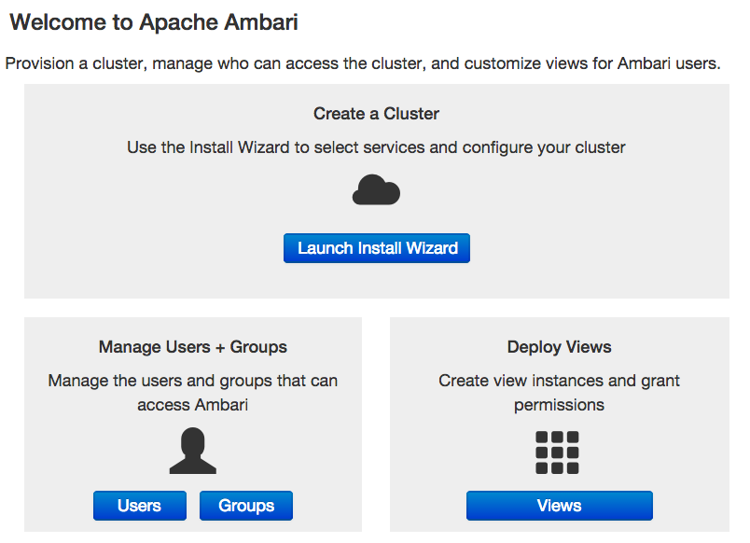

## 3. Name Your Cluster

1. In Name your cluster, type a name for the cluster you want to create. Use no white spaces or special characters in the name.
2. Choose Next.

## 4. Select Stack

The Service Stack (the Stack) is a coordinated and tested set of HDP components. Use a radio button to select the Stack version you want to install. To install an HDP 2x stack, select the HDP 2.3, HDP 2.2, HDP 2.1, or HDP 2.0 radio button.

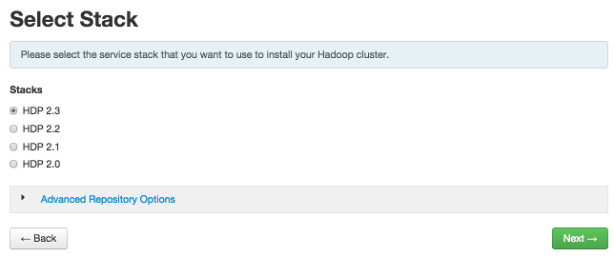

Expand Advanced Repository Options to select the Base URL of a repository from which Stack software packages download. Ambari sets the default Base URL for each repository, depending on the Internet connectivity available to the Ambari server host, as follows:

* For an Ambari Server host having Internet connectivity, Ambari sets the repository Base URL for the latest patch release for the HDP Stack version. For an Ambari Server having NO Internet connectivity, the repository Base URL defaults to the latest patch release version available at the time of Ambari release.
* You can override the repository Base URL for the HDP Stack with an earlier patch release if you want to install a specific patch release for a given HDP Stack version. For example, the HDP 2.1 Stack will default to the HDP 2.1 Stack patch release 7, or HDP-2.1.7. If you want to install HDP 2.1 Stack patch release 2, or HDP-2.1.2 instead, obtain the Base URL from the HDP Stack documentation, then enter that location in Base URL.
* If you are using a local repository, see [Using a Local Repository](http://docs.hortonworks.com/HDPDocuments/Ambari-2.1.2.0/bk_Installing_HDP_AMB/content/_using_a_local_repository.html) for information about configuring a local repository location, then enter that location as the Base URL instead of the default, public-hosted HDP Stack repositories.

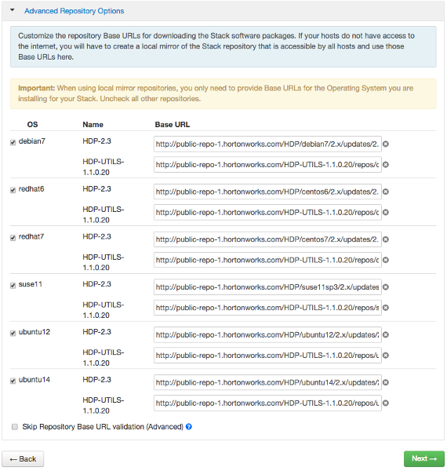

|  |  |
| --- | --- |
| [Note] | **Note** |
| The UI displays repository Base URLs based on Operating System Family (OS Family). Be sure to set the correct OS Family based on the Operating System you are running. The following table maps the OS Family to the Operating Systems. |

**Operating Systems mapped to each OS Family**

|  |  |
| --- | --- |
| **OS Family** | **Operating Systems** |
| redhat7 | Red Hat 7, CentOS 7, Oracle Linux 7 |
| redhat6 | Red Hat 6, CentOS 6, Oracle Linux 6 |
| sles11 | SUSE Linux Enterprise Server 11 |
| ubuntu12 | Ubuntu 12 |
| ubuntu14 | Ubuntu 14 |
| debian7 | Debian 7 |

## 5. Install Options

In order to build up the cluster, the install wizard prompts you for general information about how you want to set it up. You need to supply the FQDN of each of your hosts. The wizard also needs to access the private key file you created in [Set Up Password-less SSH](http://docs.hortonworks.com/HDPDocuments/Ambari-2.1.2.0/bk_Installing_HDP_AMB/content/_set_up_password-less_ssh.html). Using the host names and key file information, the wizard can locate, access, and interact securely with all hosts in the cluster.

1. Use the Target Hosts text box to enter your list of host names, one per line. You can use ranges inside brackets to indicate larger sets of hosts. For example, for host01.domain through host10.domain use host[01-10].domain

|  |  |
| --- | --- |
| [Note] | **Note** |
| If you are deploying on EC2, use the **internal Private DNS** host names. |

1. If you want to let Ambari automatically install the Ambari Agent on all your hosts using SSH, select Provide your SSH Private Key and either use the Choose File button in the Host Registration Information section to find the private key file that matches the public key you installed earlier on all your hosts or cut and paste the key into the text box manually.

|  |  |
| --- | --- |
| [Note] | **Note** |
| If you are using IE 9, the Choose File button may not appear. Use the text box to cut and paste your private key manually.  Fill in the user name for the SSH key you have selected. If you do not want to use root , you must provide the user name for an account that can execute sudo without entering a password. |

1. If you do not want Ambari to automatically install the Ambari Agents, select Perform manual registration. For further information, see [Installing Ambari Agents Manually](http://docs.hortonworks.com/HDPDocuments/Ambari-2.1.2.0/bk_ambari_reference_guide/content/ch_amb_ref_installing_ambari_agents_manually.html).
2. Choose Register and Confirm to continue.

## 6. Confirm Hosts

Confirm Hosts prompts you to confirm that Ambari has located the correct hosts for your cluster and to check those hosts to make sure they have the correct directories, packages, and processes required to continue the install.

If any hosts were selected in error, you can remove them by selecting the appropriate checkboxes and clicking the grey Remove Selected button. To remove a single host, click the small white **Remove** button in the Action column.

At the bottom of the screen, you may notice a yellow box that indicates some warnings were encountered during the check process. For example, your host may have already had a copy of wget or curl. Choose Click here to see the warnings to see a list of what was checked and what caused the warning. The warnings page also provides access to a python script that can help you clear any issues you may encounter and let you run Rerun Checks.

|  |  |
| --- | --- |
| [Note] | **Note** |
| If you are deploying HDP using Ambari 1.4 or later on RHEL 6.5 you will likely see Ambari Agents fail to register with Ambari Server during the Confirm Hosts step in the Cluster Install wizard. Click the Failed link on the Wizard page to display the Agent logs. The following log entry indicates the SSL connection between the Agent and Server failed during registration: INFO 2014-04-02 04:25:22,669 NetUtil.py:55 - Failed to connect to https://<ambari-server>:8440/cert/ca due to [Errno 1] _ssl.c:492: error:100AE081:elliptic curve routines:EC_GROUP_new_by_curve_name:unknown group |

For more information about this issue, see the [Ambari Troubleshooting Guide](http://docs.hortonworks.com/HDPDocuments/Ambari-2.1.2.0/bk_ambari_troubleshooting/content/ch_ambari_troubleshooting.html).

When you are satisfied with the list of hosts, choose Next.

## 7. Choose Services

Based on the Stack chosen during Select Stack, you are presented with the choice of Services to install into the cluster. HDP Stack comprises many services. You may choose to install any other available services now, or to [add services](http://docs.hortonworks.com/HDPDocuments/Ambari-2.1.2.0/bk_Ambari_Users_Guide/content/_adding_a_service.html) later. The install wizard selects all available services for installation by default.

1. Choose none to clear all selections, or choose all to select all listed services.
2. Choose or clear individual checkboxes to define a set of services to install now.
3. After selecting the services to install now, choose Next.

## 8. Assign Masters

The Ambari install wizard assigns the master components for selected services to appropriate hosts in your cluster and displays the assignments in Assign Masters. The left column shows services and current hosts. The right column shows current master component assignments by host, indicating the number of CPU cores and amount of RAM installed on each host.

1. To change the host assignment for a service, select a host name from the drop-down menu for that service.
2. To remove a ZooKeeper instance, click the green minus icon next to the host address you want to remove.
3. When you are satisfied with the assignments, choose Next.

## 9. Assign Slaves and Clients

The Ambari installation wizard assigns the slave components (DataNodes, NodeManagers, and RegionServers) to appropriate hosts in your cluster. It also attempts to select hosts for installing the appropriate set of clients.

1. Use **all** or **none** to select all of the hosts in the column or none of the hosts, respectively.

If a host has an asterisk next to it, that host is also running one or more master components. Hover your mouse over the asterisk to see which master components are on that host.

1. Fine-tune your selections by using the checkboxes next to specific hosts.
2. When you are satisfied with your assignments, choose Next.

## 0. Customize Services

Customize Services presents you with a set of tabs that let you manage configuration settings for HDP components. The wizard sets reasonable defaults for each of the options here, but you can use this set of tabs to tweak those settings. You are strongly encouraged to do so, as your requirements may be slightly different. Pay particular attention to the directories suggested by the installer.

Hover your cursor over each of the properties to see a brief description of what it does. The number of tabs you see is based on the type of installation you have decided to do. A typical installation has at least ten groups of configuration properties and other related options, such as database settings for Hive and Oozie, and Service Accounts information.

You must provide database passwords for the Hive and Oozie services, the Master Secret for Knox, and a valid email address to which system alerts will be sent. Select each service that displays a number highlighted red. Then, fill in the required field on the Service Config tab. Repeat this until the red flags disappear.

For example, Choose Hive. Expand the Hive Metastore section, if necessary. In Database Password, provide a password, then retype to confirm it, in the fields marked red and "This is required."

|  |  |
| --- | --- |
| [Note] | **Note** |
| By default, Ambari will install a new MySQL instance for the Hive Metastore and install a Derby instance for Oozie. If you plan to use existing databases for MySQL, Oracle or PostgreSQL, modify these options before proceeding. Refer to [Using Non-Default Databases](http://docs.hortonworks.com/HDPDocuments/Ambari-2.1.2.0/bk_ambari_reference_guide/content/ch_amb_ref_using_non_default_databases.html#header) for more information on using existing databases. |
| [Important] | **Important** | |
| Using the **Microsoft SQL Server** or **SQL Anywhere** database options are not supported. | |

The service account users and groups are available under the Misc tab. These are the OS accounts the service components will run as. There is also an option to skip group modification. This tells Ambari to not modify group membership for the service users. If your environment does not allow groupmod or usermod , you need to select this “skip” option. See [Customizing HDP Services](http://docs.hortonworks.com/HDPDocuments/Ambari-2.1.2.0/bk_ambari_reference_guide/content/ch_amb_ref_customizing_hdp_services.html) for more information on service account users and groups.

To configure Oozie with HTTPs, see [Configuring HTTPS for the Oozie Server](http://docs.hortonworks.com/HDPDocuments/Ambari-2.1.2.0/bk_Installing_HDP_AMB/content/_config_HTTPS_for_Oozie.html).

After you complete Customizing Services, choose Next.

## 11. Review

The assignments you have made are displayed. Check to make sure everything is correct. If you need to make changes, use the left navigation bar to return to the appropriate screen.

To print your information for later reference, choose Print.

When you are satisfied with your choices, choose Deploy.

## 12. Install, Start and Test

The progress of the install displays on the screen. Ambari installs, starts, and runs a simple test on each component. Overall status of the process displays in progress bar at the top of the screen and host-by-host status displays in the main section. Do not refresh your browser during this process. Refreshing the browser may interrupt the progress indicators.

To see specific information on what tasks have been completed per host, click the link in the Message column for the appropriate host. In the Tasks pop-up, click the individual task to see the related log files. You can select filter conditions by using the Show drop-down list. To see a larger version of the log contents, click the Open icon or to copy the contents to the clipboard, use the Copy icon.

When Successfully installed and started the services appears, choose Next.

## 13. Complete

The Summary page provides you a summary list of the accomplished tasks. Choose Complete. Ambari Web GUI displays.